**REF: Project for sustainable Water, Sanitation, Hygiene, and Agriculture Programm in Pageri Payam Magwi County, Eastern Equatoria State, South Sudan**

**Project No: *2015.1542.8***

**Introduction:**

Bengo/IAS German signed an agreement with Community Action Water Programm and

Edooss on the 19th June 2015 for the project for Sustainable Water, sanitation, hygiene,

and agriculture in Pageri Payam Magwi County, Eastern Equatoria State, South Sudan

**Project purpose**

The goal of the project is to improve the livelihood of the people of Pageri payam by provision of safe drinking water, promotion of hygiene and sanitation; and knowledge on improved agriculture. Its specific objectives are:

1. improve access to safe water.
2. Improve community wide hygiene and sanitation practices
3. Increased and sustained food production in the primary school and community at large.

**Implementation strategic for 2016 activities**

January 2016 activities. Field visits from 27th - 30th, three meetings held with the government official in the Payam and the school management for

* Planning purposes for 2016 project activities
* Two quarter activities evaluation for 2015 done together with the school management, PTA and government representatives.
* 16 water cans, 30 empty sack for storage and harvested knifes were delivered to the four school through the office of Education department in the Pageri payam

***Drilling and construction of boreholes***

* Preparation and services of the drilling equipments, meachinary on going in Yei.
* Site clearing and the road for the drilling trucks to pass easily are on progress at Royal kids and Kerepi primary schools respectiviely
* Movement of the drilling crew, mechinary from Yei base to Pageri drilling site via Juba has been set throught the help of the managing Director.
* Local materials, sand, bricks, stone and aggregate collection for the two boreholes to be drilled are on going at Kerepi and Royal kids primary schools
* Consultation and preparation of drilling materials, spare parts and fuels for the remaining two site are on progress.

***Fencing of the borehole***

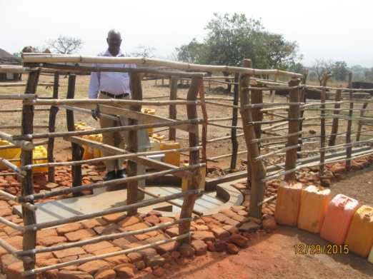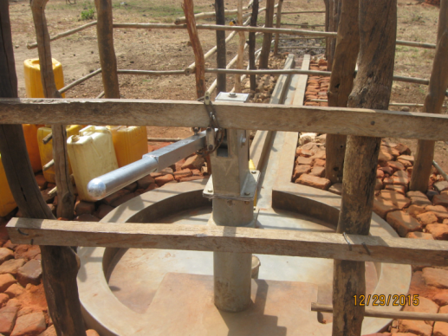

***Why fencing the water points:***

1. It is control mechanism by the water committee for easy management of the borehole
2. Prevent children from playing at the water points
3. Animal will not have access of conteminating the water points
4. To avoid conflict by the communities during fetching first come first serve
5. School children lessons will not be interrupted by the people who come to fetch water.

***Bio-sandfilter construction and distribution***

*Not done*

***School garden***

***Harvesting***

*Harvesting of the crops was done in Dec 2015. The harvest of Orobe primary school was very good. However the harvest of Royal Kids and Kerepi Child Hope primary schools though good was not to our expectation. The exact number of sacks will be reported when the harvest is threshed.*

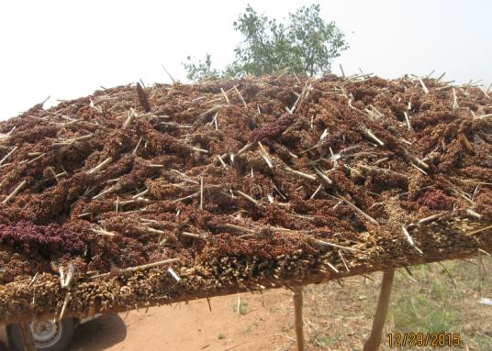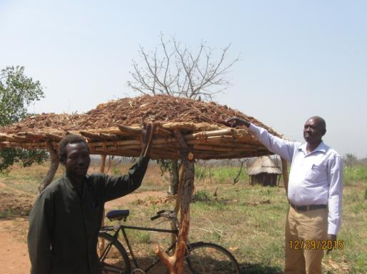

***Additional garden tools***

*Additional garden tools were distributed on 28-01=2016, these comprise watering cans, sacks for storage of the harvested food, and knives to aid harvesting.*

|  |  |  |  |
| --- | --- | --- | --- |
|  | *Watering cans* | *Sacks* | *Knives* |
| *Orobe P.S.* | *4* | *10* | *10* |
| *Royal Kids P.S.* | *4* | *10* | *10* |
| *Kerepi Child Hope P.S.* | *4* | *10* | *10* |
| *Kerepi P.S.* | *4* | *10* | *10* |

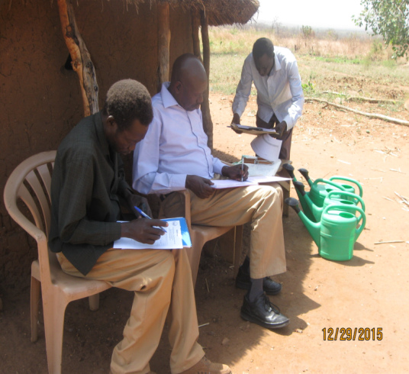

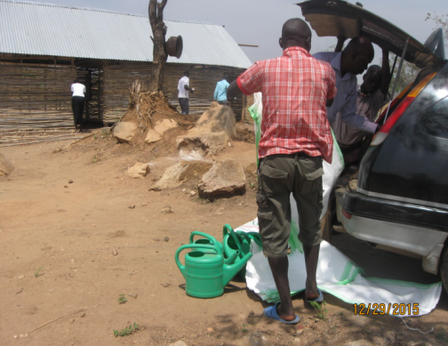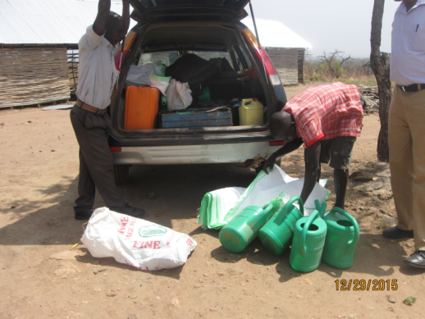

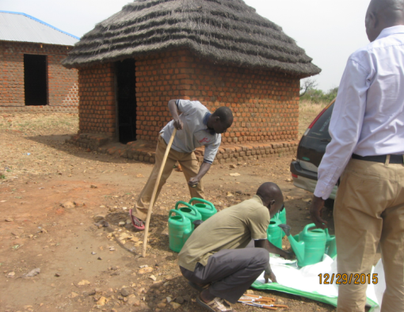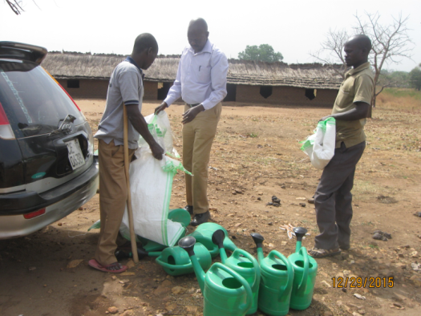

***Meetings***

*Meetings were held in Royal Kids and Kerepi Child Hope to lay strategies for 2016 school garden project. The two schools planned to increase the garden size in 2016, Royal Kids said they would use 100mx200m land in addition to their former land and Kerepi Child Hope promised to use an additional 100x100m land. The two schools said they would start their vegetable garden in Feb, 2016. We are glad to point here that the County Agric Department said they would help the schools with expertise and supervision of the school gardens while the parents of the school children said they would help with most of the activities of the school garden.*

*The meetings in Orobe P.S. and Kerepi P.S. are planned for 1st Week of Feb, 2016.*

***Challenges***

* *Delayment in the implementation of the signed agreement between the SPLA in opposition and the government*
* *The economic crisis kept on moving from bad to worse as such living standard become expensive, due to scarcity of food commodaties in the market and high prcies*
* *Some of the investors who do import supplies from other countries have not yet return to South Sudan hence the cost of spare parts, schools garden supplies, constructional materials become very expensive compared to 2015*

***Possible solutions***

* *The requested additional budget if approved will help supplement the current budget and ease the financial challenge for this quarter activities.*
* *The imposed sanction by the UN and international body will mount pressure on the two leaders to start implementation of the signed peace agreement in Addis Ababa*
* *Supplies which are not availiabel in Juba could be purchase from neighboring County – Uganda for the project activities in pageri*

***Comments***

* *Two meetings were conducted with the authority of Pageri Payam on regard to the activities accomplished.*
* *Plan for 2016 remaining project acitivities were discussed, hence the Payam authority are requesting extension of the project to the areas which are in desparete needs.*
* *Sanitary facilities in the three schools was requested to give a full component of Agriculuture water and sanitation.*
* *Appreciation from the Pageri Area Administrator (commissioner) for supporting his people with long term developmental project.*